Class Led Practice:

1. Answer each of the following. Assume that single-precision floating-point numbers are stored in 4 bytes, and that the starting address of the array is at location 1002500 in memory. Each part of the exercise should use the results of previous parts where appropriate.

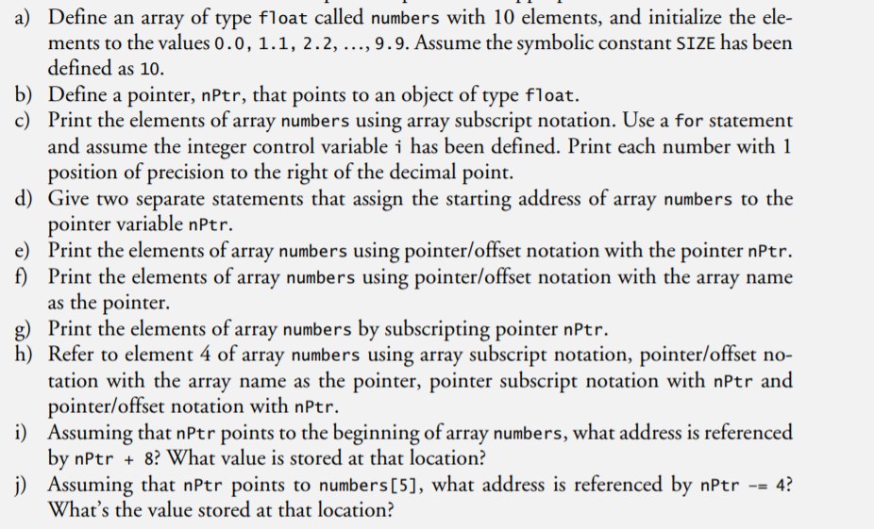

1. For each of the following, write a statement that performs the indicated task. Assume that floating-point variables number1 and number2 are defined and that number1 is initialized to 7.3.

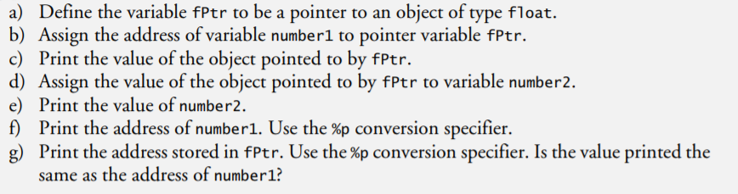

1. Do each of the following:

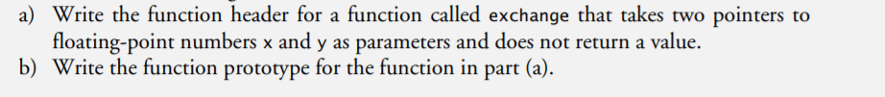

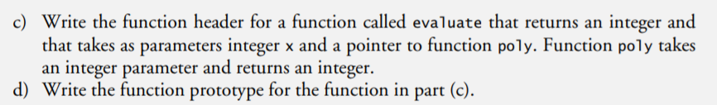

4.\*\*\*\*\*\*\*\*\*\*\*\*\*\*\*\*\*\*\*\*\*\*\*\*\*\*\*

